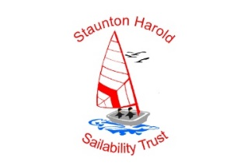 | Staunton Harold Sailability Trust
Feedback Form
Name : (optional) …………………………………………………………….
- What is it that makes you want to come to Sailability?

- What do you like most at the sessions and why?

- What do you least like and why?

- What else would you like to be able to do at our sessions?

- Would you be interested in becoming a trustee with the charity?

- Would you consider promoting our charity in workplaces, with friends and family?

- As a parent or supporter the club is introducing a supporter membership for £10 per year, this gives you free access to the club and savings on prices for club social events, would you be happy to join and like more information?

- In 2024 the club is opening up Sailability memberships for both Juniors (under 18) and Adults (0ver 18) priced this entitles you to sail whenever the club is open and to use the trust boats and equipment, it also means free attendance to our sessions, is this something you would like more information about?

- Most of our sessions are on a Sunday morning is this the best day or would you prefer another day or time, if so when and why?

- Please make an other comments positive or negative to help us understand how we are doing.

